Text Classification – Notable Figures and Tables from the Literature

Text Classification Algorithms: A Survey by Kowsari et al.
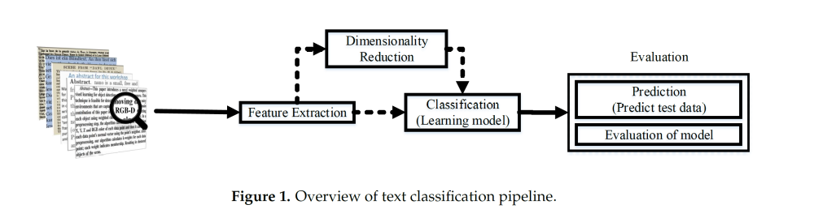
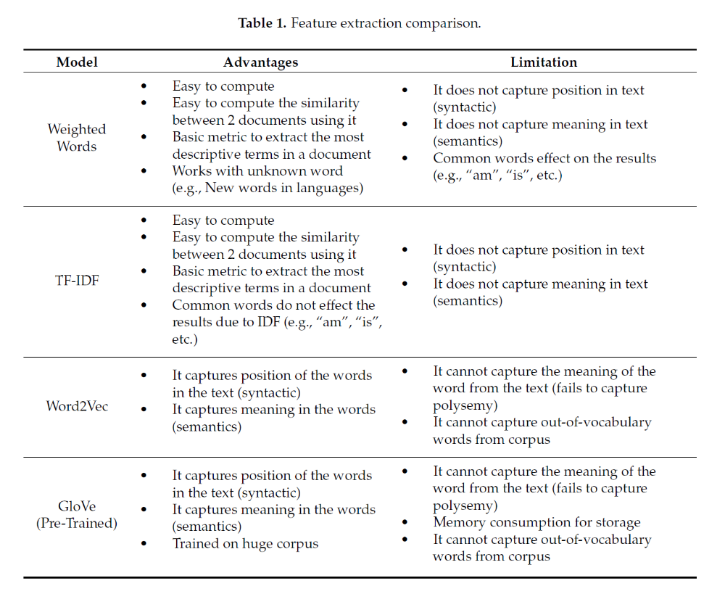
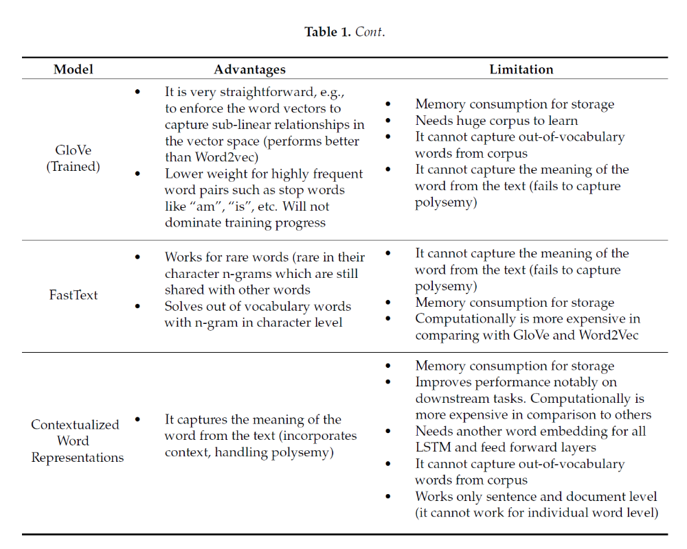

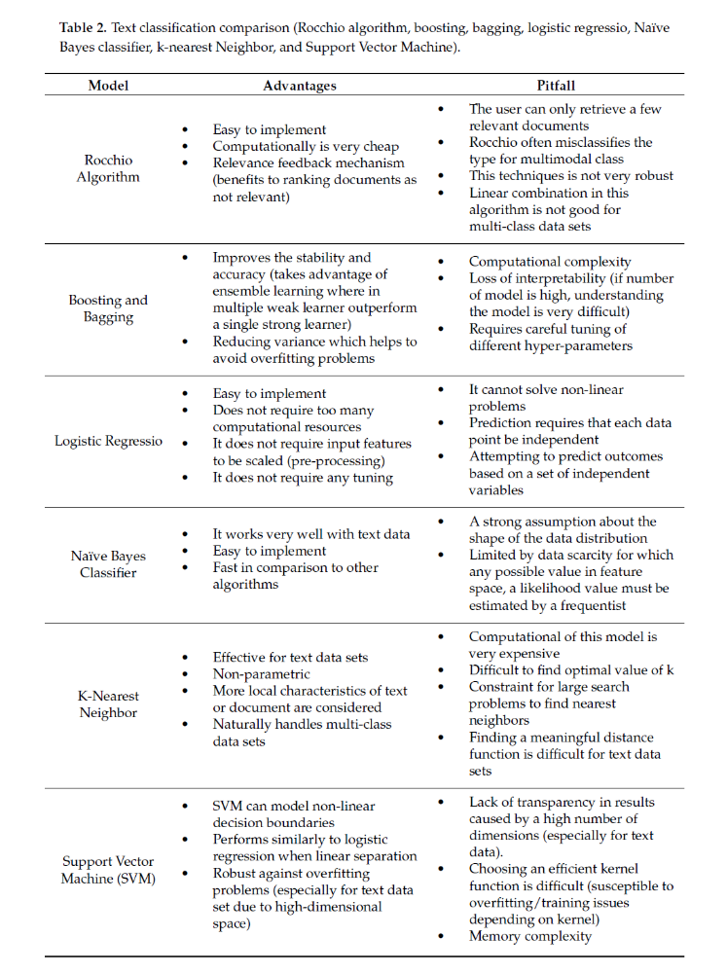
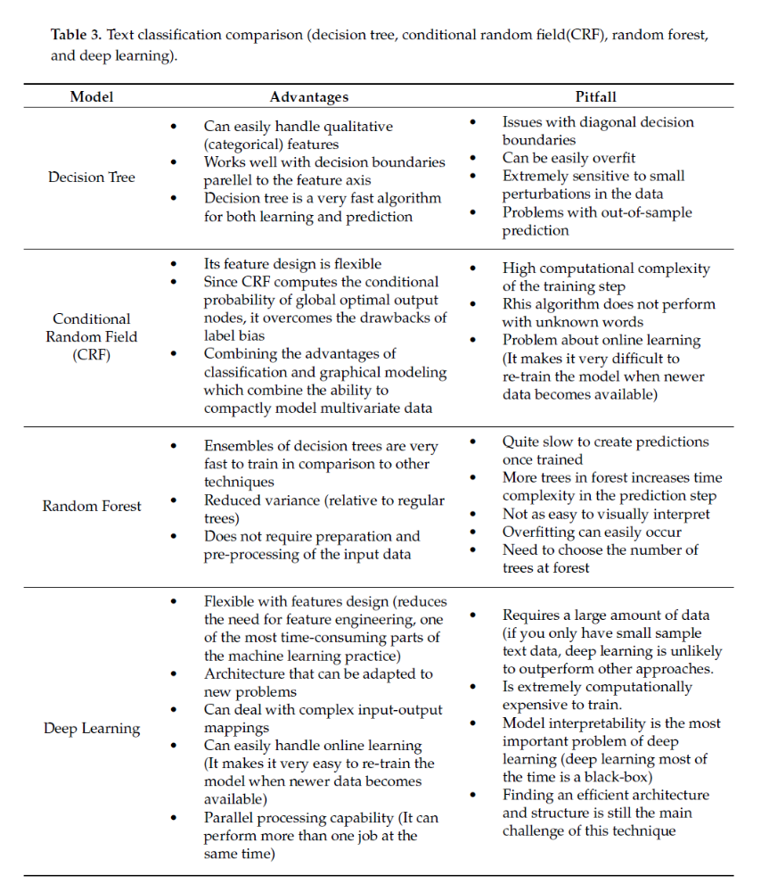

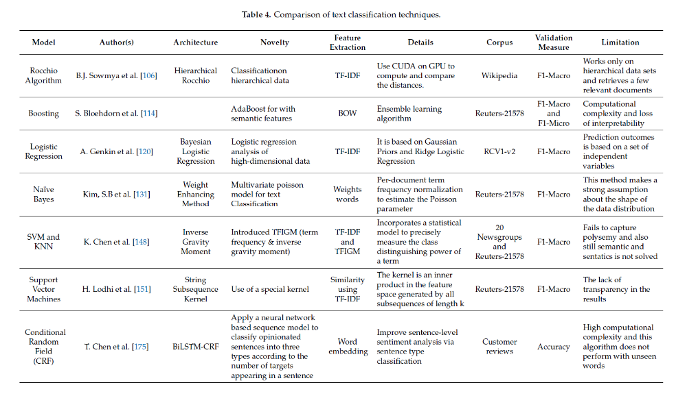
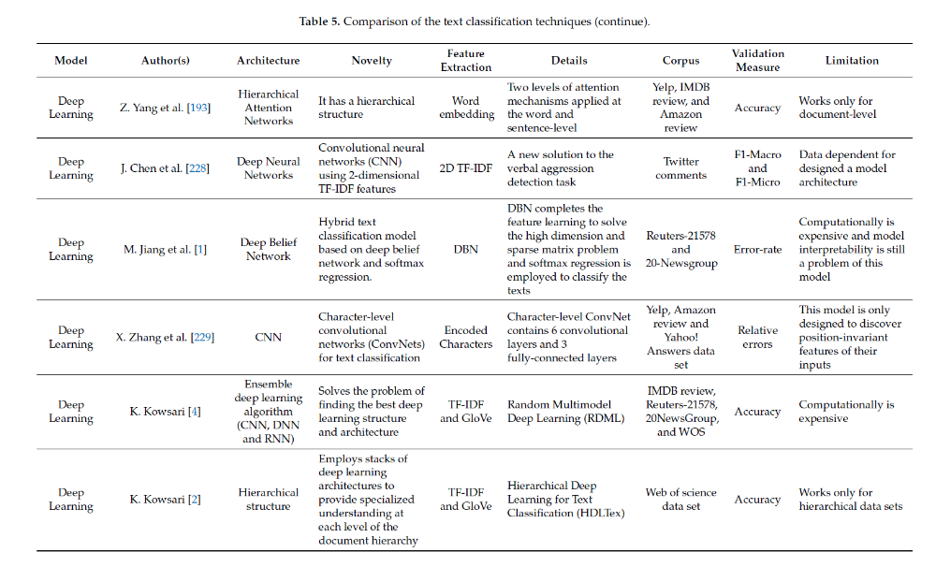

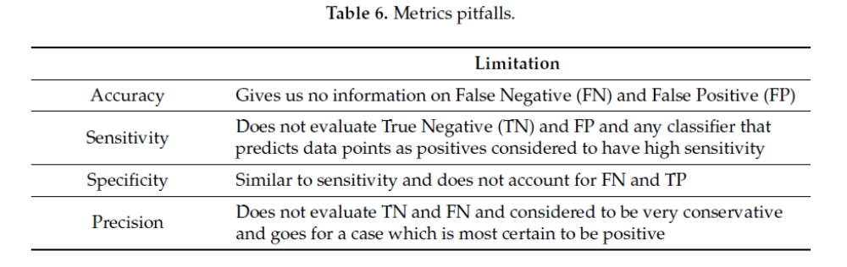

Article Classification Using Natural Language Processing and Machine Learning

A Recent Overview of the State-of-the-Art Elements of Text Classification

